Name: Muhammad Taha | CMS ID:518133
1st Semester | BSCS

Lesson Set 5 | Conditional Statements
Purpose | - To work with relational operators  - To work with conditional statements  - To learn and use logical operators
Procedure | - Students should read the Pre-lab Reading Assignment before coming to lab.  - Students should complete the Pre-lab Writing Assignment before coming to lab.  - Instructor will give further instructions as to grading and completion of the lab.  - Students should complete the set of lab tasks before the next lab and get them checked by their lab instructor.
 | Contents | Pre-requisites | Completion Time | Page Number
 | Pre-lab Reading Assignment | - | 30 min | 2
 | Pre-lab Writing Assignment | Pre-lab Reading | 10 min | 6
 | Lab 5
 | Lab 5.1  Relational Operators and if Statement | Pre-lab reading | 30 min | 7
 | Lab 5.2  if/else Statement | Basic Understanding of If/else | 30 min | 7
 | Lab 5.3  Working with Logical Operators. | Basic Understanding of  Logical Operators | 30 min | 7
 | Lab 5.4  Lab Tasks | Understanding of  Conditional Statement and Usage | 60 min | 9

PRE-LAB READING
ASSIGNMENT
Relational Operators | You have already seen that the statement total = 5 is an assignment statement; that is, the integer 5 is placed in the variable called total. Nothing relevant to our everyday understanding of equality is present here. So how do we deal with equality in a program? How about greater than or less than? C++ allows the programmer to compare numeric values using relational operators. They are the following:  > Greater than  < Less than  > = Greater than or equal to  < = Less than or equal to  = = Equal to  ! = Not equal to  An expression of the form num1 > num2 is called a relational expression. Note that it does not assert that num1 is greater than num2. It actually tests to see if this is true. So relational expressions are boolean. Their value must be either true or false. The statement cost!=9 is false if the cost has value 9 and is true otherwise.  Consider the following code:  int years;  years = 6; // assignment statement years is assigned the value of 6  years == 5; // relational expression, not an assignment statement  years = years - 1; // assignment statement  years != 5; // relational expression
The if Statement | Sometimes we may only want a portion of code executed under certain conditions. To do so, we use conditional statements. For example, if you are writing a payroll program to compute wages, then the program should only compute overtime pay if the employee worked more than 40 hours per week. Otherwise, when the program is executed the overtime portion of the code should be bypassed. An if statement is one kind of conditional statement.  Consider the following program:  Sample Program 5.1:  // This program prints "You Pass" if a student's average is 60 or higher and prints  // "You Fail" otherwise  #include using namespace std:  int main() {  float average;  cout << "Input your average" << endl;  cin >> average;  if (average >= 60) // note the use of a relational operator  cout << "You Passed" << endl;  if (average < 60)  cout << "You Failed" << endl; return 0; }  Note that it is not possible for this program to print out both “You Pass” and “You Fail”. Only one of the if statements will be executed. Later we will see a way to write this program without using 2 if statements.  If you want to conditionally execute several statements using if, the following syntax is required:  if (expression)  {  statement_1;  statement_2;  statement_n;  }  Note the curly braces surrounding the set of statements to be conditionally executed
The if/else Statement | In Sample Program 5.1 we used two if statements. A more elegant approach would be to use the if/else statement as follows:  if (average >= 60)  cout << "You Passed" << endl;  else  cout << "You Failed" << endl;  In every if/else statement the program can take only one of two possible paths. Multiple statements can be handled using curly braces in the same way as the if statement.
The if/else if Statement | In Sample Program 5.1 we used two if statements. A more elegant approach would be to use the if/else statement as follows:  if (average >= 60)  cout << "You Passed" << endl;  else  cout << "You Failed" << endl;  In every if/else statement the program can take only one of two possible paths. Multiple statements can be handled using curly braces in the same way as the if statement.  The if/else statement works well if there are only two possible paths to follow. However, what if there are more than two possibilities? For example, suppose we need to decide what kind of vacation to take based on a yearly work bonus:  if the bonus is less than $1,000, we set up a tent and eat hot dogs in the back yard  if the bonus is less than $10,000 and greater than or equal to $1,000, we go to  Disney World  if the bonus is $10,000, we go to Hawaii  We could code this using the if/else if statement as follows:  float bonus;  cout << "Please input the amount of your yearly bonus" << endl;  cin >> bonus;  if (bonus < 1000)  cout << "Another vacation eating hot dogs on the lawn" << endl;  else if (bonus < 10000)  cout << "Off to Disney World!" << endl;  else if (bonus == 10000)  cout << "Lets go to Hawaii!" << endl;  Can you explain why the first else if conditional statement does not require a greater than or equal to 1000 condition?  In general, we can use as many else if expressions as needed to solve a given problem.
The Trailing else | What happens in the code above if the bonus entered is greater than $10,000? Actually, nothing will happen since none of the conditional expressions are true in this case. Sometimes it is advantageous to add a final or trailing else at the end of a chain of if/else if statements to handle “all other cases.” For example, we could modify the code to read:  if (bonus < 1000)  cout << "Another vacation on the lawn" << endl;  else if (bonus < 10000)  cout << "Off to Disney World!" << endl;  else if (bonus == 10000)  cout << "Lets go to Hawaii!" << endl;  else {  cout << bonus << " is not a valid bonus" << endl;  cout << "Please rerun the program with valid data" << endl;  } // Note the necessary use of the curly brackets here  Of course, few would complain about a bonus greater than $10,000 and the Hawaii trip could still be done on this budget. However, if the maximum possible bonus is $10,000, then the trailing else will let the user know that an illegal value has been entered.

Logical Operators | By using relational operators C++ programmers can create relational expressions. Programmers can also combine truth values into a single expression by using logical operators. For example, instead of a statement such as “if it is sunny, then we will go outside,” one may use a statement such as “if it is sunny and it is warm, then we will go outside.” Note that this statement has two smaller statements “it is sunny” and “it is warm” joined by the AND logical operator. To evaluate to true, both the sunny and warm requirements must be met.  The NOT operator negates a single statement. For example, “it is sunny” can be negated by “it is not sunny.”  The OR operator is similar to the AND in that it connects two statements. However, there is an ambiguity about the meaning of the word or in English. In the statement “tonight at 8:00 I will go to the concert in the park or I will go to the stadium to see the ball game,” the word or is exclusive. That is, I can go to the concert or to the game, but not both. However, in the statement “I need to draw an ace or a king to have a good poker hand,” the word or is inclusive. In other words, I can draw a king, an ace, or even both, and I will have a good hand. So we have a choice to make. Let A and B be two statements. A OR B could mean A or B but not both. It could also mean A or B or both. In computer science we use the second meaning of the word or. For example, in the statement “if it is sunny or it is warm, then I will go outside,” there are three scenarios where I will go outside: if it is sunny but not warm, if it is warm but not sunny, or if it is sunny and warm. The syntax used by C++ for logical operators is the following:  AND &&  OR | |  NOT !  Consider the following:  if (dollars <= 0 || !(accountActive) )  cout << " You may not withdraw money from the bank";  It is good programming practice to enclose the operand after the (!) operator in parentheses. Unexpected things can happen in complicated expressions if you do not. When will this code execute the cout statement? What type of variable do you think accountActive is?

PRE-LAB WRITING ASSIGNMENT

Fill-in-the-Blanks | - The two possible values for a relational expression are > and <.  - C++ uses the && symbol to represent the AND operator.  - In C++ is the meaning of the OR logical operator inclusive or exclusive? inclusive.  - C++ uses the || symbol to represent the OR operator.  - It is good programming practice to do what to the operand after the NOT operator Avoid Double Not operator.

LAB 5.1
Relational Operators and the if Statement | // This program tests whether or not an initialized value  // is equal to a value input by the user  // Taha 518133  #include using namespace std;  int main( )  {  int num1, // num1 is not initialized  num2 = 5; // num2 has been initialized to 5  cout << "Please enter an integer" << endl;  cin >> num1;  cout << "num1 = " << num1 << " and num2 = " << num2 << endl;  if (num1 == num2)  cout << "Hey, that’s a coincidence!" << endl;  if (num1 != num2)  cout << "The values are not the same" << endl;  return 0;  }
LAB 5.2
if/else if Statements | // This program prints "You Pass" if a student's average is  // 60 or higher and prints "You Fail" otherwise  // Taha 518133  #include using namespace std;  int main()  {  float average; // holds the grade average  cout << "Input your average:" << endl;  cin >> average;  if (average > 60)  cout << "You Pass" << endl;  if (average < 60)  cout << "You Fail" << endl;  return 0;  }
LAB 5.3
Logical Operators | // This program illustrates the use of logical operators  // Taha 518133  #include using namespace std;  int main() {  char year;  float gpa; cout << "What year student are you ?" << endl;  cout << "Enter 1 (freshman), 2 (sophomore), 3 (junior), or 4 (senior)"  << endl << endl;  cin >> year;  cout << "Now enter your GPA" << endl;  cin >> gpa;  if (gpa >= 2.0 && year == '4')  cout << "It is time to graduate soon" << endl;  else if (year != '4'|| gpa<2.0)  cout<< "You need more schooling" << endl;  return 0;  }

LAB 5.4 | Lab Tasks
1 | Write a C++ program that takes as input 5 numbers from the user and displays the maximum of the 5 numbers using if else.  #include <iostream>  using namespace std;  int main() {  int num1, num2, num3, num4, num5;  cout << "Enter 5 numbers:" <<endl;  cin >> num1 >> num2 >> num3 >> num4 >> num5;  int max = num1;  if (num2 > max) {  max = num2;  }  if (num3 > max) {  max = num3;  }  if (num4 > max) {  max = num4;  }  if (num5 > max) {  max = num5;  }  cout << "The maximum number is: " << max <<endl;  return 0;  }  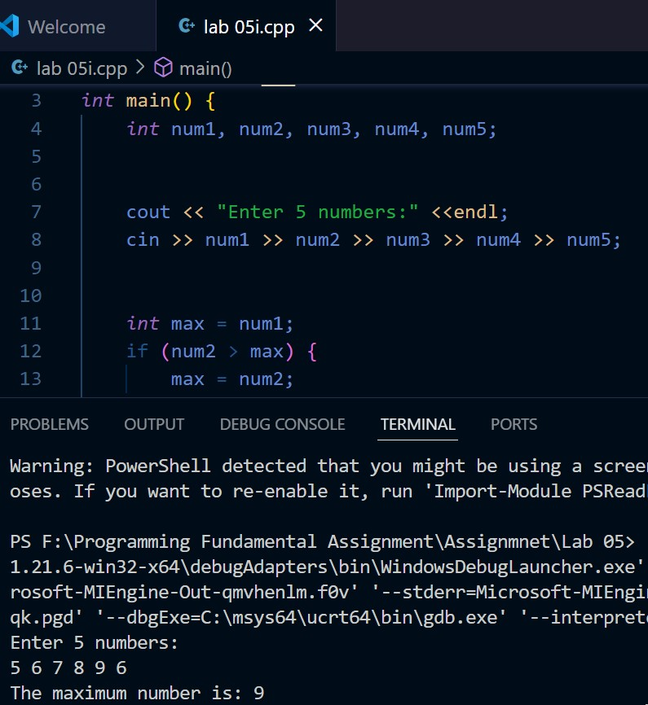
2 | Write a C++ program to check whether a number entered by the user is even or odd using if else. Hint made use of the modulus operator (%) to find if the number is even or odd.  #include <iostream>  using namespace std;  int main() {  int number;  cout << "Enter a number: ";  cin >> number;  if (number % 2 == 0) {  cout << number << " is even." << endl;  } else {  cout << number << " is odd." << endl;  }  return 0;  }  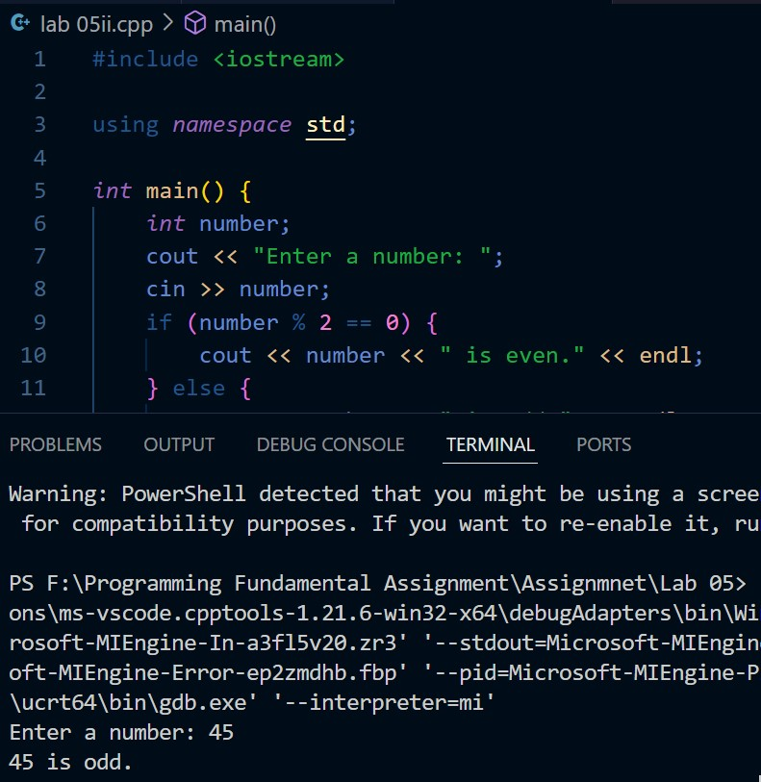
3 | Rewrite the code in task 2 by using a switch instead of if-else.  #include <iostream>  using namespace std;  int main() {  int number;  cout << "Enter a number: ";  cin >> number;  switch (number % 2) {  case 0:  cout << number << " is even." << endl;  break;  case 1:  cout << number << " is odd." << endl;  break;  default:  cout << "Error: unexpected value." << endl;  break;  }  return 0;  }  